News Release

Humble Business Partners with Non-Profit Organization
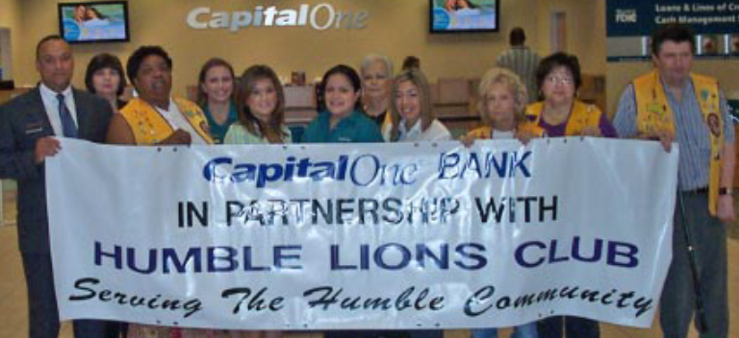
The Humble’s Capitol One Bank is giving back to the community. They are new to Humble, says Elgin Weaver, Asst. VP and Marketing Manager, but are already partnering with the Humble Lions Club, a not for profit 501.C3 organization. They will support Humble Lions Clubs activities including Food Baskets, school supplies and the 5th Annual Humble Lions Bike Ride in raising funds to send Special Needs Children to Summer Camp, at absolutely no cost to their parents. Lions Clubs send children to the Texas Lions Camp in Kerrville, Texas. The Bike Ride, a BP / MS 150 recommended ride, is to be held at the Humble Civic Center Arena. You can contact the Humble Lions Club at Phone # 281-360-9901 or on our web site at www.humblelionsclub.com.

