News Release
Non Profit Organization Partners with Humble Business
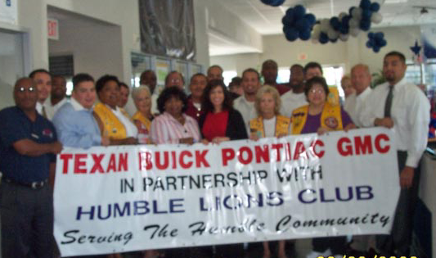

The TEXAN Buick, Pontiac, and GMC Dealership of Humble is Partnering with the Humble Lions Club, a not for profit 501.C3 organization. Gwen Faltesek Exec. Asst. and co-workers representing TEXAN, are proud to be able to give back to the community by supporting the 5th Annual Humble Lions Bike Ride in sending Special Needs Children to Summer Camp at absolutely no cost to their parents. Lions Clubs send children to the Texas Lions Camp in Kerrville, Texas. Other up coming Humble Lions Club events include a BBQ Cook Off, and Fish Fry. The Bike Ride is a BP / MS 150 recommended ride. You can contact the Humble Lions Club at Phone Number 281-360-9901 or on our web site at www.humblelionsclub.com.

